**PRACTICAL -11**

# **AIM: Introduction about the menus and toolbar in Page maker**

1. **Menu bar -**

It contains the following menus File, Edit, Layout, Type, Element, Utilities, View, Window, Help. When you click on a menu item, a pulldown menu appears. There may be sub-menus under certain options in the pull-down menus. Refer Figure 2.6

1. **Toolbar** -

If you place the mouse pointer on a button in the Toolbar, a short text will appear with its description called ‘Tool Tip’. Refer Figure 2.7



* Fig- Toolbar & Menu bar

**PRACTICAL -12**

# **AIM: Setting up a page size in page maker**

## Steps to create a new page document.

1. Start the adobe page maker PageMaker window will be opened
2. Choose File > New in the menu bar (or) Press Ctrl+ N in the Keyboard. This opens the Document Setup dialog box
3. 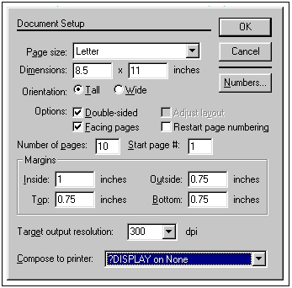Fig – Document Setup
4. Click the Page Size drop down list box and select A4 size .
5. In the Number of pages text box, type 4.
6. Set the values in the Margins sections as follows:

Inside - 1.00 inches

Outside. - 0.75 inches

Top. - 0.75 inches

Bottom. - 0.75 inches

1. Click on OK. Now a new document called Untitled 1 will Appear on the screen as shown in Figure.

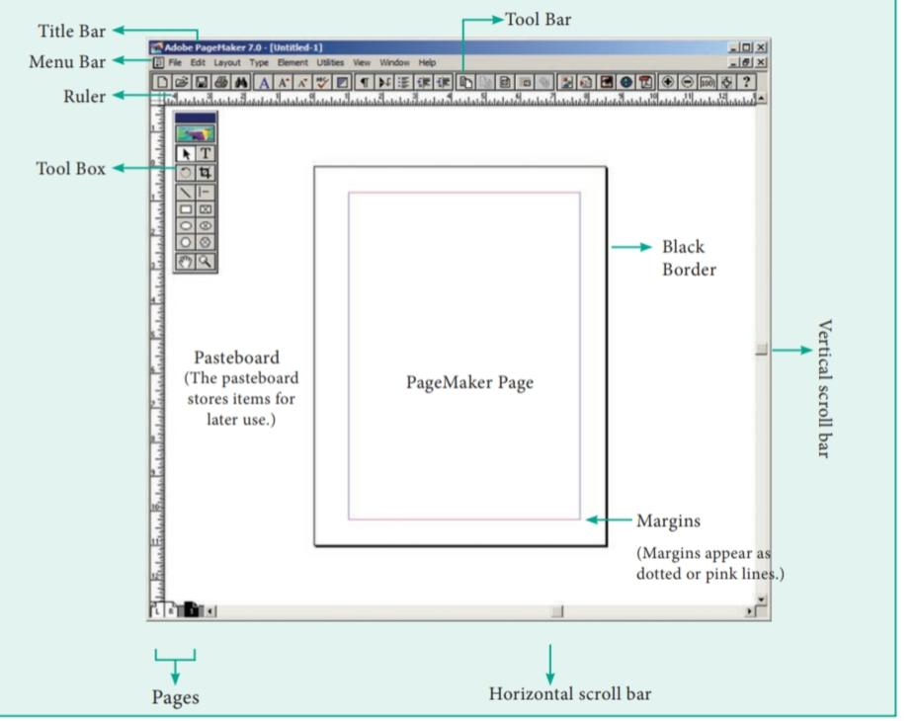

Fig- workspace

1. Click on the Text tool and create a text block. Then type The text in text block.
2. If the user wants to edit the text like to change font size, colour, bold, italic, select the text and then edit.
3. To save the document ,Press Ctrl + S (or) Choose File > Save in the menu bar. Save publication dialogue box appears. Type the File name text box and press Save button.

**PRACTICAL -13.**

# **AIM: Step to save and close a publication**

* **Saving a Publication**

To save a new publication, you can click the Save button on the Standard toolbar or click either Save or Save As on the File menu. You can then specify the publication s name and storage location. Follow these steps:

1. On the File menu, click Save As.
2. Publisher displays the Save As dialog box, as shown here:

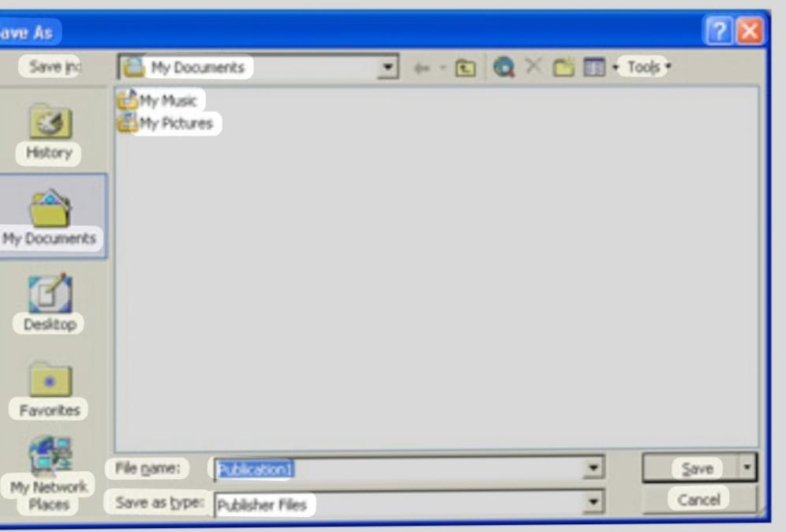

Saving options

By default, publications are saved with the Publisher Files format, and templates are saved with the Publisher Template format. To save a file with a different format, in the Save As dialog box, click the down arrow to the right of the Save as type box, and in the drop-down list, select the format you need. If you want to keep a backup copy of your work, click the down arrow to the right of the Save button in the Save As dialog box, and then in the drop-down list, click Save with Backup.

1. With Publication1 highlighted in the File name box, type Postcard to replace Publisher s suggested name.
2. Be sure that the My Documents folder appears in the Save in box and, leaving the other settings in the dialog box as they are, click Save.

When you return to the publication, notice that Postcard has replaced Publication1 in the title bar.

* 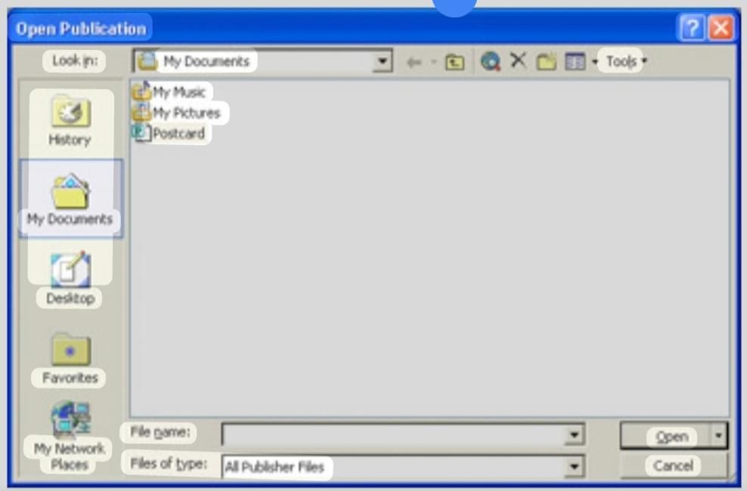**Closing and opening a Publication**

Now that you ve saved the postcard so that its information is stored, you can get some practice in closing its file and then opening it again. Let s get going:

1. On the File menu, click Close.

The Postcard publication disappears from view, and a blank publication takes its place.

1. On the Standard toolbar, click the Open button.

The Open Publication dialog box appears, as shown in this graphic:

**PRACTICAL – 14**

# **AIM: Steps to apply spelling and grammar checking and correction**

It is important to always check your documents for spelling and grammar mistakes before distribution. Fortunately, Word makes it easy.

This feature works the same in all modern versions of Microsoft Word.

* 1. From the Proofing group on the Review tab, select Spelling & Grammar.

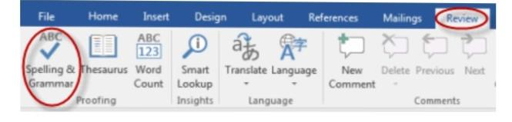

* 1. Microsoft Word will look for spelling and grammar errors starting from the location of your cursor in the document.
  2. If Word finds a spelling error, a navigation pane similar to the one below will appear:

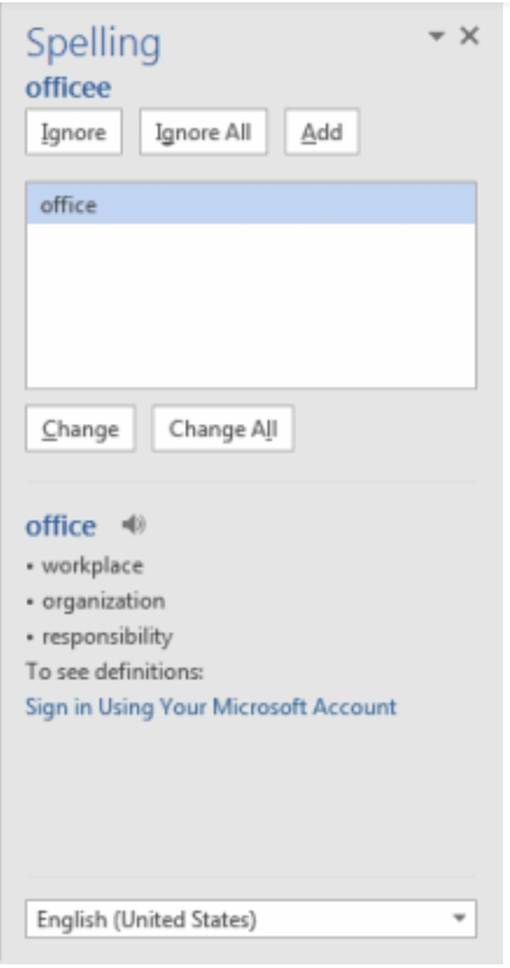

* 1. If Word finds a grammar error, a dialog box similar to the one below will appear:

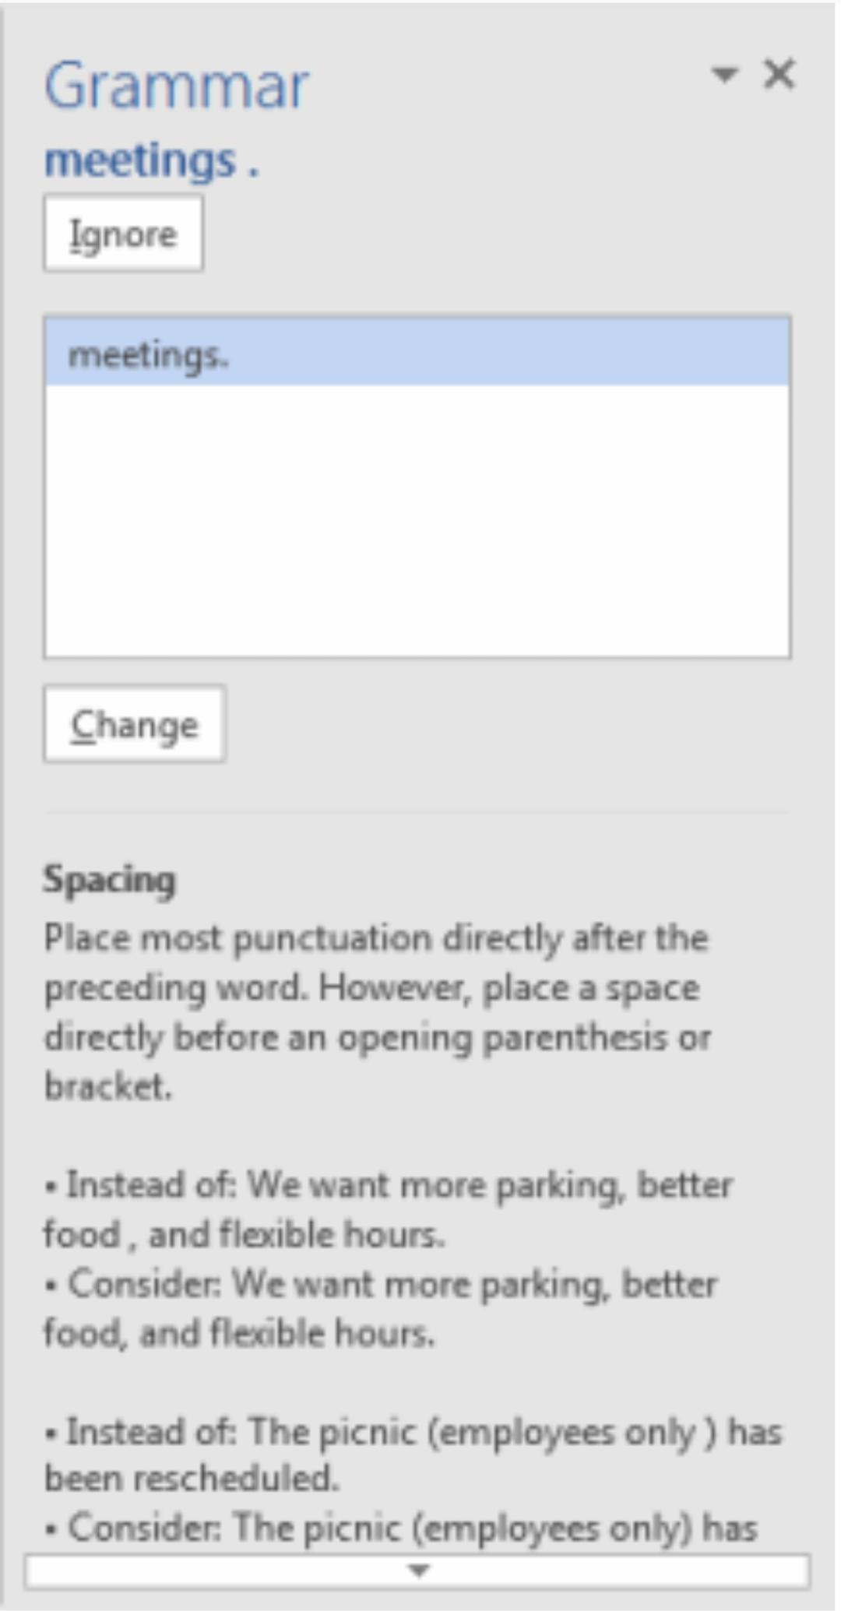

1. . Ignore leave the text as is in a specific instance, but be notified if Microsoft Word finds the same thing again, click Ignore.
2. . To Change accept Word’s suggested correction, click Change.
3. At the bottom of the pane, you will see an explanation of the grammar error that Word has detected.

**PRACTICAL – 15**

# **AIM: Step to Thesaurus in MS word**

1. Select a word in your document. Just click and draw your mouse to highlight the word you want to look up in the thesaurus. You can also just double-click the word to select it instantly.

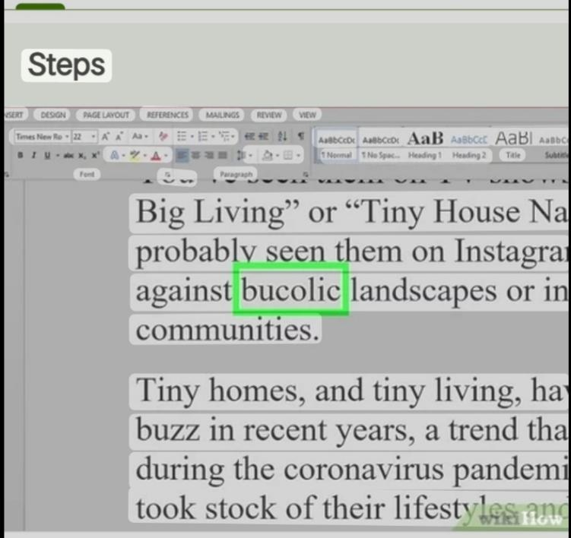

1. Right-click the highlighted word. If you don’t have a right mouse button, you can press Control as you click the word or tap the trackpad with two fingers.

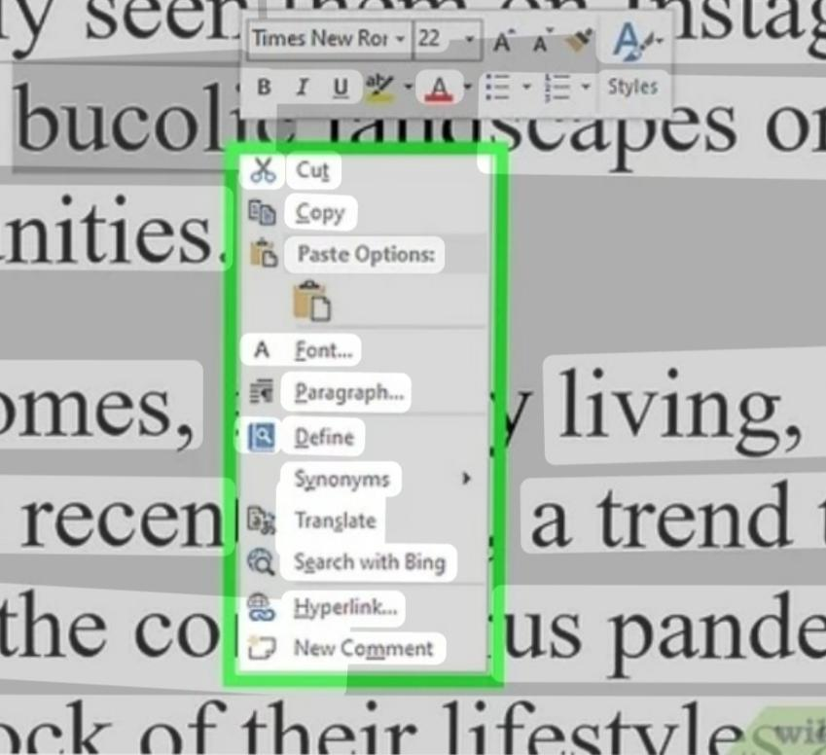

1. Click Synonyms

On the menu. Another menu will expand, displaying a few select words that have the same or similar meaning as the word you’ve selected.

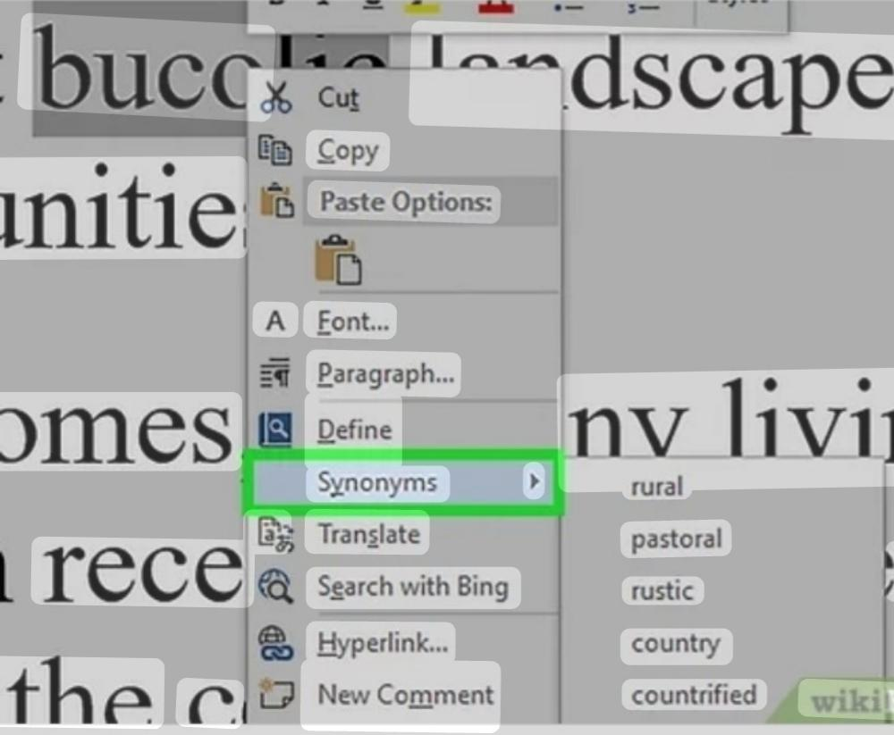

1. Click Thesaurus on the menu. This expands the Thesaurus tab on the right side of your document.

The new window displays the suggestions you saw on the previous menu, and in many cases, several other suggestions.

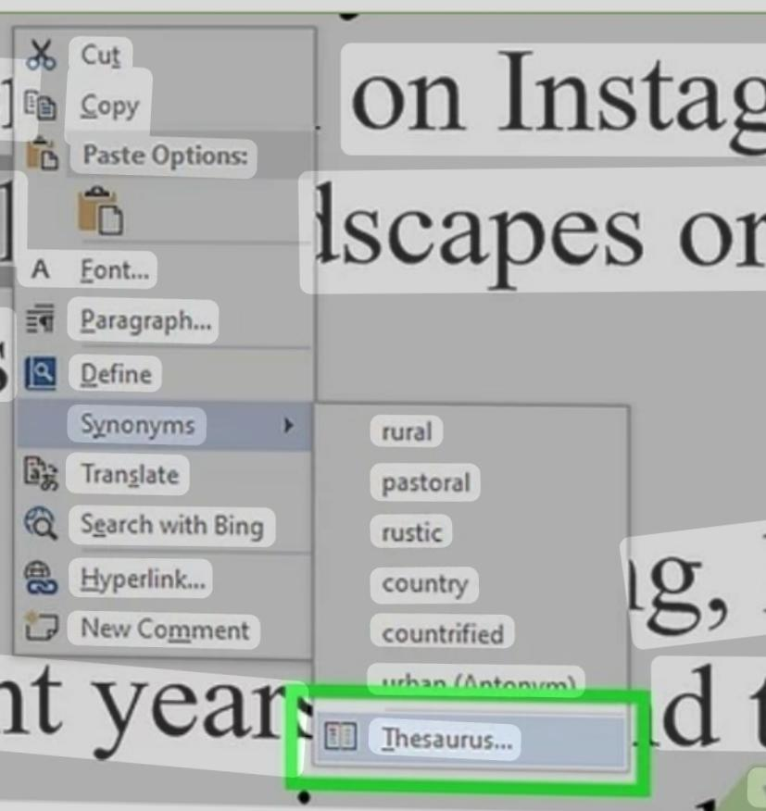

1. Click the arrow to the right of a synonym

▼. If you don’t see the arrow, hover your cursor over it first. A brief drop-down menu will expand.

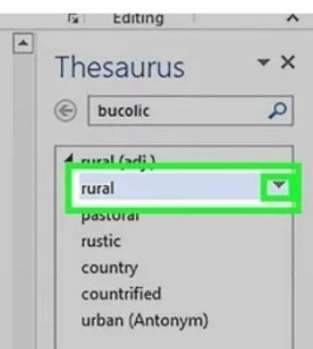

1. Click Insert. This replaces the word in your document with the selected synonym.

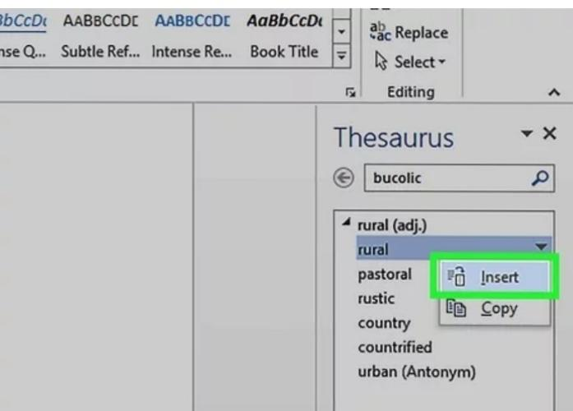

**PRACTICAL – 16**

# **AIM: Steps to Find and Replace a Text in The MS-Word Document**

1. Go to Home > Replace or press Ctrl+H.

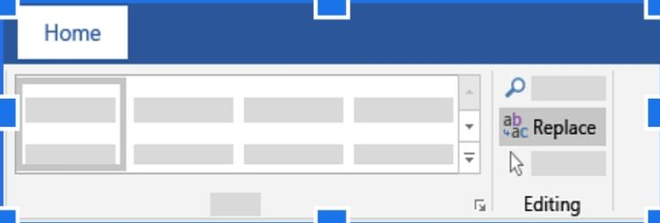

1. Enter the word or phrase you want to locate in the Find box.
2. Enter your new text in the Replace box.
3. Select Find next until you come to the word you want to update.
4. Choose Replace. To update all instances at once, choose Replace All.
5. To specify only upper or lowercase in your search, select More > Match case.

.

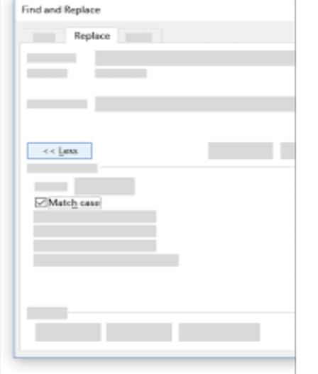

**PRACTICAL – 17**

# **AIM: Steps to Apply Bullets and Numbering In the MS-Word Document**

To create a bulleted list in Microsoft Word, follow the steps below.

1. Position the cursor where you want to insert the bullet list.
2. On the Home tab in the Ribbon, click the bullet list button, as shown at the top of the page.
3. If successful, a bullet should appear. Type any text and press to start the next bullet. To end the bullet list, press twice.
4. Below is an example of a bullet list.
5. One bullet
6. Two bullet

To create a numbered list in Microsoft Word, follow the steps below.

1. Position the cursor where you want to insert the number list.
2. On the Home tab in the Ribbon, click the number list button, as shown at the top of the page.
3. If successful, a number one should appear. Type any text and press to start the next number in the numbered list. To end the numbered list, press twice.

To create a numbered list that also contains a letter list in Microsoft Word, follow the steps below

1. Position the cursor where you want to insert the number list.
2. On the Home tab in the Ribbon, click the down arrow next to the number list button.
3. In drop-down window that appears, select one of the numbered list options with letters.
4. Type the text for the first lettered bullet item.
5. Press to add additional lettered bullet items.

**PRACTICAL – 18**

# **AIM: Steps to Use Mail Merge to use Mail Merge**

Open an existing Word document or create a new one.

From the Mailings tab, click the Start Mail Merge command and select Step-by-Step Mail Merge Wizard from the drop-down menu.

The Mail Merge pane will appear and guide you through the six main steps to complete a merge. The following example demonstrates how to create a form letter and merge the letter with a recipient list.

Step 1:

From the Mail Merge task pane on the right side of the Word window, choose the type of document you want to create. In our 23 examples, we’ll select Letters. Then click next: Starting document to move to S

Step 2:

Select Use the current document, then click Next: Select recipients to move to Step 3.

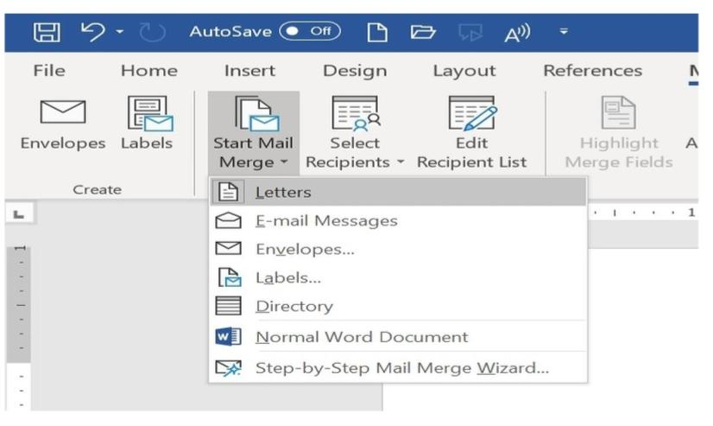

Step 3:

Now you’ll need an address list so Word can automatically place each address into the document. The list can be in an existing file, such as an Excel workbook, or you can type a new address list from within the Mail Merge Wizard.

1. Select Use an existing list, and then click Browse to select the file.
2. Locate your file, and then click Open.
3. If the address list is in an Excel workbook, select the worksheet that contains the list, and then click OK.
4. In the Mail Merge Recipients dialog box, you can check or uncheck each box to control which recipients are included in the merge. By default, all recipients should be selected. When you’re done, click OK.
5. Click Next: Write your letter to move to Step 4.

Step 4:

Now you’re ready to write your letter. When it’s printed, each copy of the letter will basically be the same; only the recipient data (such as the name and address) will be different. You’ll need to add placeholders for the recipient data, so Mail Merge knows exactly where to add the data. To insert recipient data:

1. Place the insertion point in the document where you want the information to appear.
2. Choose one of the placeholder options. In our example, we’ll select Address block.
3. Depending on your selection, a dialog box may appear with various customization options. Select the desired options, and then click OK.
4. A placeholder will appear in your document (for example, «Address Block»).
5. Add any other placeholders you want. In our example, we’ll add a Greeting line placeholder just above the body of the letter.
6. When you’re done, click next: Preview your letters to move to Step 5

Step 5:

1. Preview the letters to make sure the information from the recipient list appears correctly in the letter. You can use the left and right scroll arrows to view each version of the document.
2. If everything looks correct, click next: Complete the merge to move to Step 6.

Step 6:

1. Click Print to print the letters.
2. A dialog box will appear. Decide if you want to print all of the letters, the current document (record), or only a select group, and then click OK. In our example, we’ll print all the letters.
3. The Print dialog box will appear. Adjust the print settings if needed, then click OK. The letters will be printed.
4. Challenge!
5. Open our practice document and practice recipient list.
6. Use the Mail Merge Wizard to merge the letter with the recipient list.
7. Insert an address block at the top of the document. Choose the second format: Joshua Randall Jr.

**PRACTICAL – 19**

**AIM: Steps to use Macros**

Step 1: Open the new or an existing Word document.

Step 2: Click on the View tab on the Ribbon and click on the drop-down icon associated with the Macros in the Macros section.

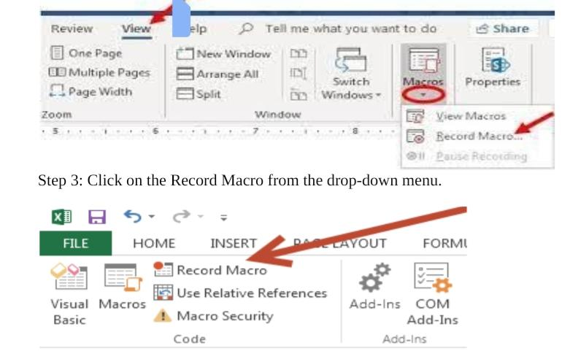

Step 4:

A Record Macro dialog box will appear on the screen in which do the following –

1. Enter the Name for the macro in the Macro name text field.
2. To use the same macro for the further document, click on the All Documents (Normal.dotm) option from the Store macro in drop- down menu.
3. Click on the Button icon in the Assign macro to section to run your macro.

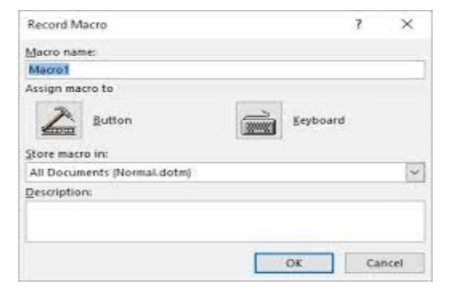

Step 5:

A word Options window will appear on the screen with highlighted Quick Access Toolbar at the left pane.

1. Click on the new macro name (Normal.NewMacros.MyMacro) on the left side of the screen.
2. Click on the Add button to add the macro on the Quick Access Toolbar at the right side of the screen.
3. Click on the Modify button, as shown in the below screenshot.

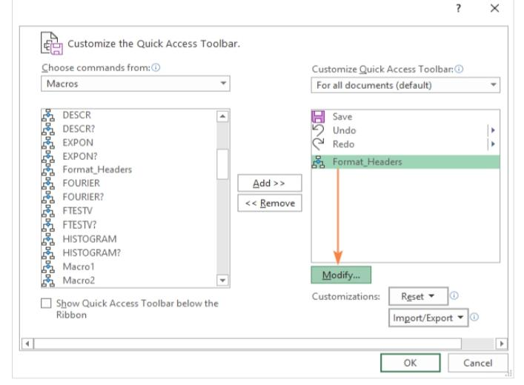

Step 6:

Select macro that you want to record from the Modify Button dialog box, type the Display name, and

click on the OK button.

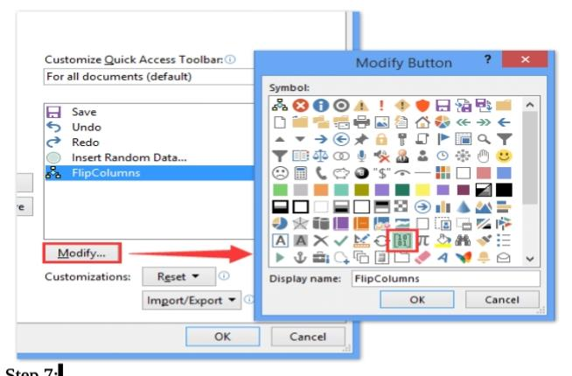

Step 7:

Click on the OK button at the Word options window.

Step 8:

Now, click on the View tab and click on the Macros drop-down menu. Click on the Stop Recording Macro from the drop-down menu.

